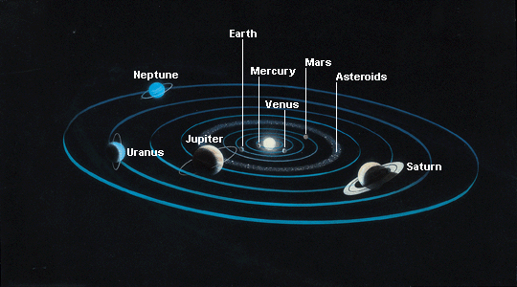
Space Explorer 2014
The Solar System is under attack by aliens! The aliens think that the Solar System is too boring, and they’re going to destroy it! You have just been hired as a top-secret space explorer by the US government. If the aliens are convinced that the Solar System is really amazing, they might not destroy it after all! Your mission is to explore a planet and report back to your commander with as much information as possible.

Task: Use Internet resources and books to find information on your assigned planet. Remember – the fate of the Solar System is in your hands, so do your best work!
Process:
- Get your planet and partner assignment from your teacher.
- Use the books that Mrs. Price and your teacher give you to research your planet.
- Use the Internet resources that Mrs. Price and your teacher show you to complete your research.
- Complete the Space Explorer task.
Evaluation:
Imagine that you are the alien who wants to destroy the solar system. Based on your research and sentences, would you save the Solar System or destroy it? Use this form to explain your decision.
Resources:
Planet books – assigned by Mrs. Price and your teacher
WorldBook Kids
Pebblego.com
How to use Pebblego.com to research your planet
- Go to pebblego.com and enter the username music43 and the password city
- Choose the Earth and Space database. It has a green background.
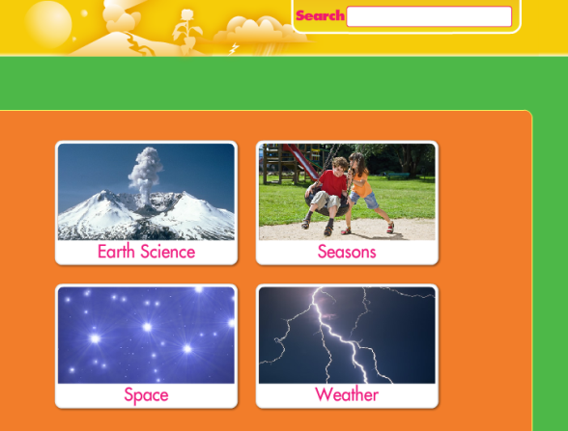
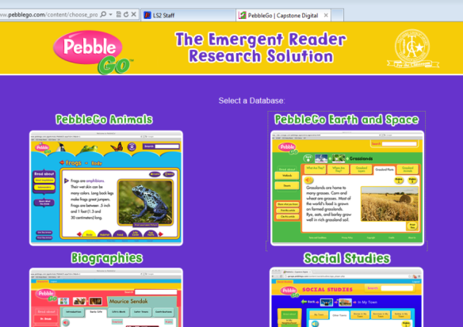
- Click “Space”

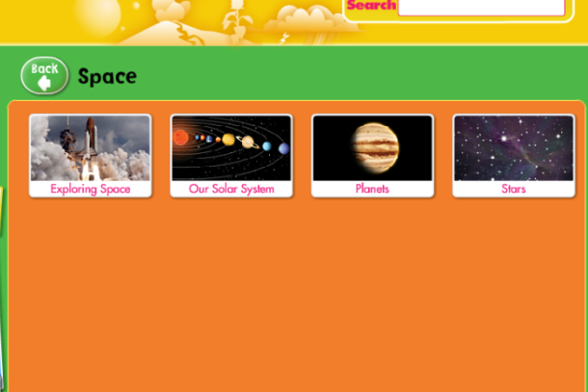

- Click Planets

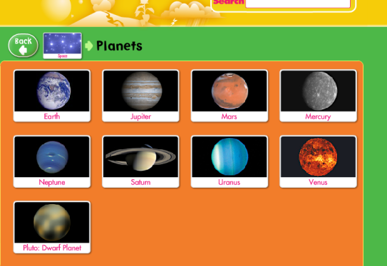
- Click your assigned planet

